JIMMY REITER LIVE
Release Date Jan 15 2021, PogoPop Musik / Membran, JGOP004, CD (Digipak) / Download

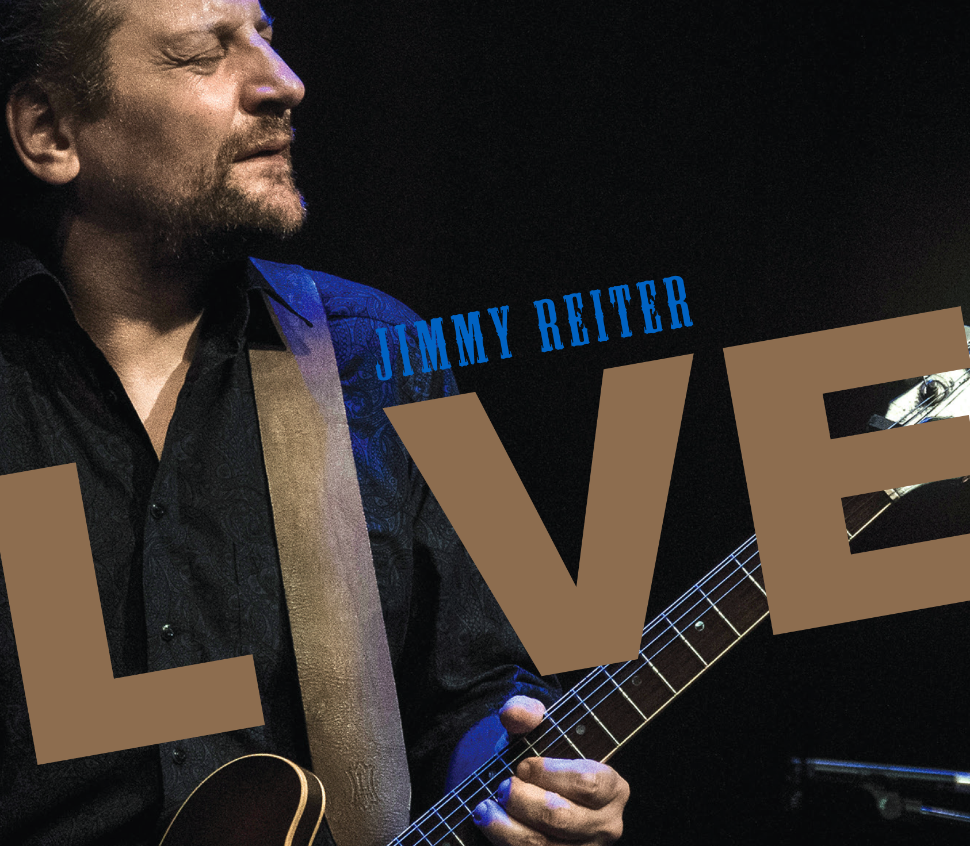
Whether from a small club stage or a large outdoor festival, the Jimmy Reiter Band is well-known for their spirited shows and sharing their passion for blues with their audiences, as is well documented on the band's upcoming album "Live", recorded in Osnabrück, Germany and Vienna, Austria. Filled with almost 80 minutes of material from their previous studio albums as well as long-time audience favorites, Reiter and his band are at the top of their game, doing what they love the most.

"People have been asking for a live CD for a long time. When the COVID-19 pandemic forced us to put our touring plans on hold in 2020, we decided to go through all the live material that we had recorded over the last year or so and pick out our personal favorites," says Reiter about the decision to release his first ever concert recording.

Jimmy Reiter toured the length and breadth of Europe as lead guitarist with US Blues singer/harmonica player Doug Jay for over 10 years and released "High Priest Of Nothing" in 2011, his solo debut as a frontman. The CD won the German Record Critics' Award and launched his career as a bandleader in his own right. Two more studio albums followed, "Told You So" in 2015 and "What You Need" in 2019, both praised by fans and critics alike. Extensive European touring established the Jimmy Reiter Band as a class act in the international Blues world. The rhythm section of Björn Puls (drums) and Jasper Mortier (bass) has been the core of the group since the first CD, with Nico Dreier completing the quartet on piano and organ since 2016.

"Jimmy Reiter demonstrated why he is considered one of the top
acts of the current blues scene." (ORF, Austrian broadcasting corporation)

"Live" was partly recorded at the band’s annual concert in January of 2020 at the "Blue Note" club in Reiter’s hometown of Osnabrück, Germany. For the event, The Jimmy Reiter Band was augmented by special guests Dmitry Suslov (tenor sax) and Jürgen Wieching (baritone sax), adding a further dimension to these recordings. The remaining songs are taken from a show at the "Vienna Blues Spring“, broadcast on Austrian radio by ORF in 2019.

The set kicks off with "Waiting For My Luck To Change" from Reiter’s second album, followed by "What You Need", the title track of his most recent studio CD and the first of six tracks from that album revitalized for "Live". The extended slow blues "Give It To Me Straight" is a highlight, giving plenty of room for Reiter to stretch out on guitar and showing the band's mastery of dynamics - at one point so whisper-quiet that one can hear the creaking of the boards onstage. "Jimmy’s Boogie", a fiery tribute to his guitar heroes Freddie King and Magic Sam, finishes off the set, leaving a wildly enthusiastic audience behind.

LINE-UP Jimmy Reiter (guitar, vocals), Nico Dreier (keys), Jasper Mortier (bass, backing vocals), Björn Puls (drums, backing vocals) SPECIAL GUESTS Dmitry Suslov (tenor sax), Jürgen Wieching (baritone sax) PRODUCED BY Jimmy Reiter and Marcus Praed RECORDED LIVE AT Reigen, Vienna (April 4, 2019) and Blue Note, Osnabrück (January 9, 2020) DETAILS www.jimmyreiter.com/live

TRACK LIST 1. Waiting For My Luck To Change 2. What You Need 3. What's In It For Me? 4. Too Many Cooks 5. I Shouldn't But I Do 6. Hard Times (Have Surely Come) 7. I'll Take The Easy Way 8. Give It To Me Straight 9. Woman Don't Lie 10. It's Easy When You Know How 11. I'm Givin' In 12. Hooked 13. Who's Minding The Store? 14. Jimmy's Boogie

